Table of Contents

Employee Logs In 2

Games Management 2

View Games 2

Add Game 3

Edit Game 3

Delete Game 4

Events Management 5

View Events 5

Add Event 6

Edit Event 6

Delete Event 7

Reports 7

View Reports 7

View a Report 8

Manage Shipments 8

View Pending Shipments 8

Update Ship Status 9

Manage Reviews 9

View Pending Reviews 9

Publish Review 9

Reject Review 9

# Employee Logs In

Employee Clicks on Employees tab and enters login information 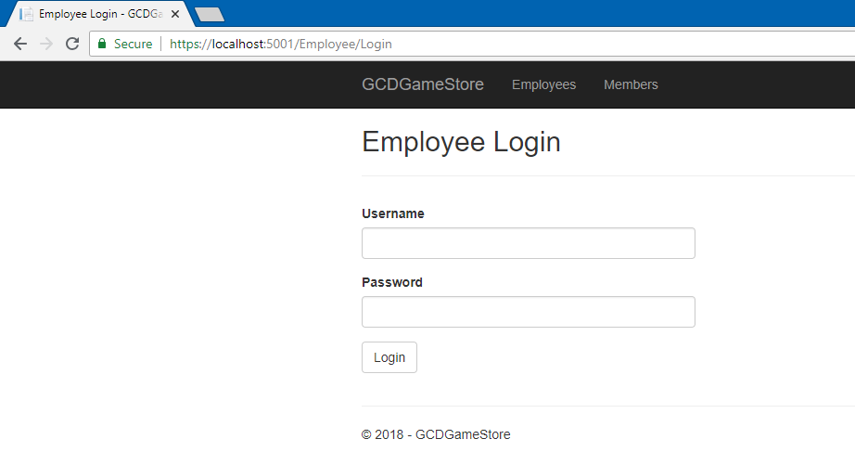

# Games Management

## View Games

Click on Games Menu Button

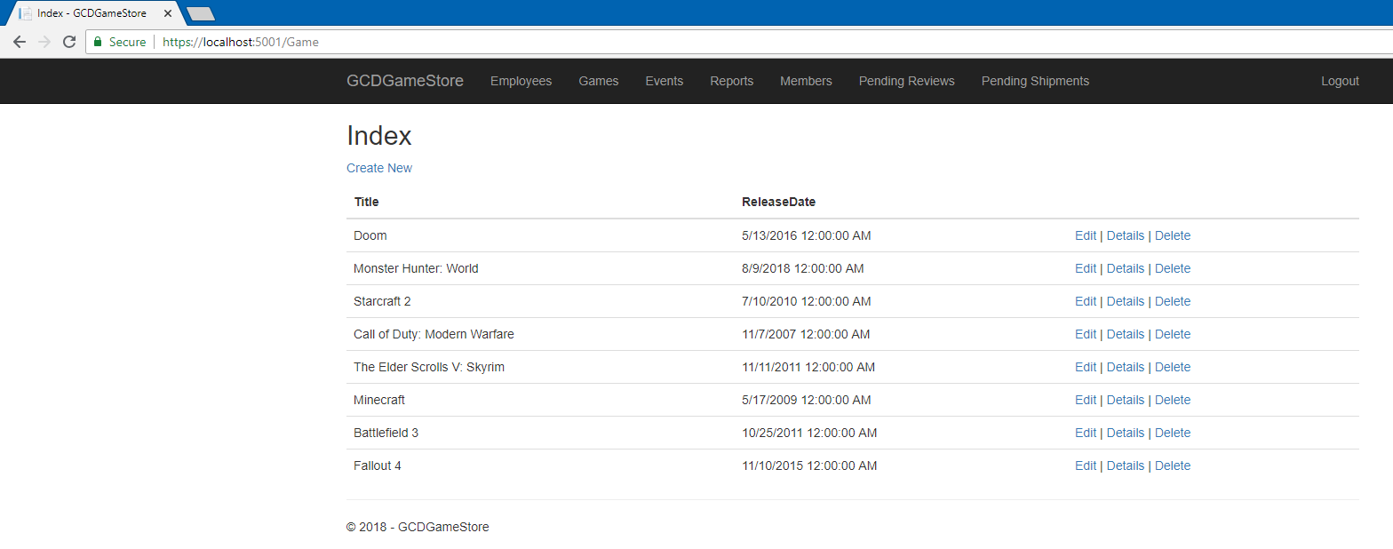

## Add Game

Click Create New From View Games Page

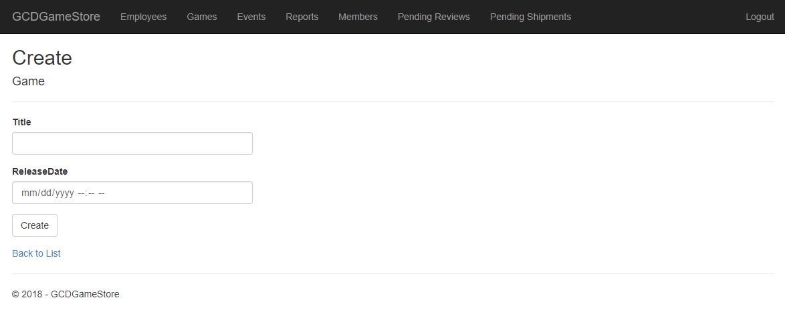

Fill out the game information and click create.

## Edit Game

Click Edit For a Game From The View Games Page



Edit the game information and click save.

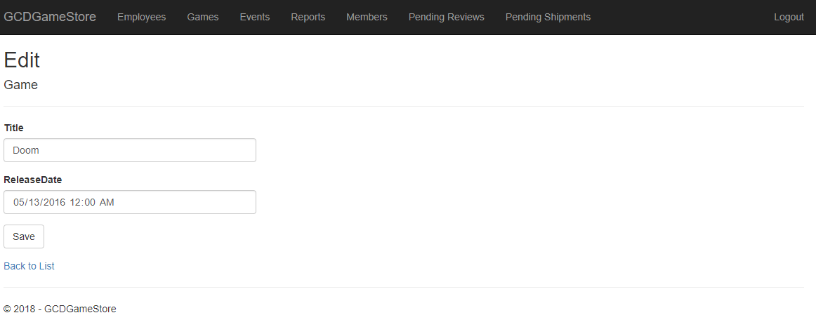

## Delete Game

Click Delete For a Game From The View Games Page



Click Delete

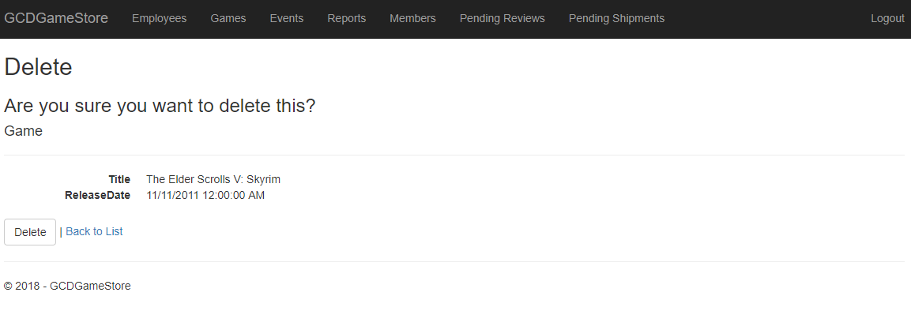

# Events Management

## View Events

Click Events Menu Button

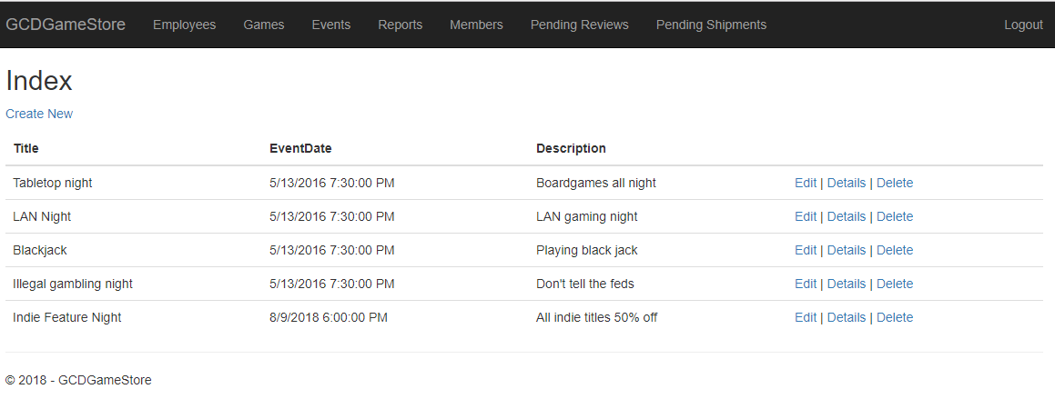

## Add Event

From the view events page click Create New

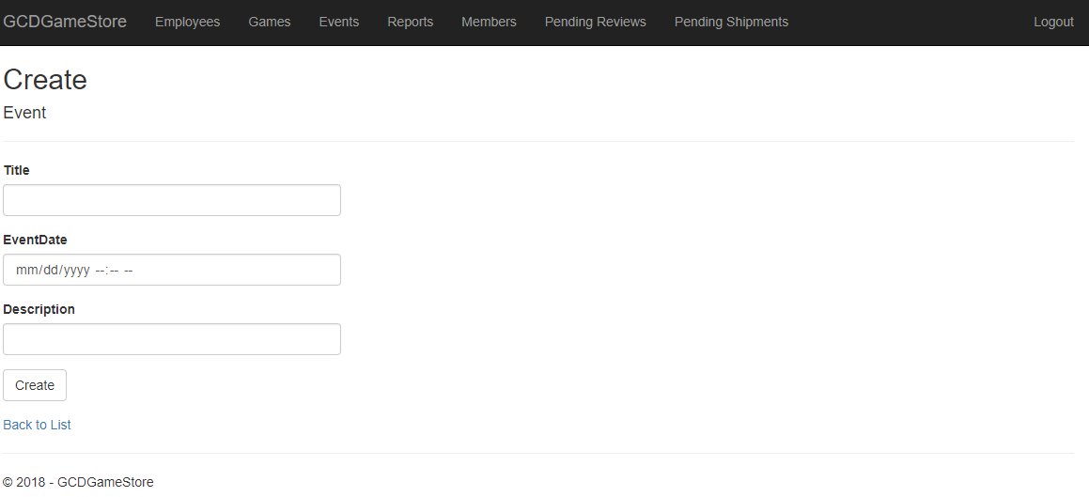

Fill in the event information and click Create

## Edit Event

From the view events page click Edit for an event

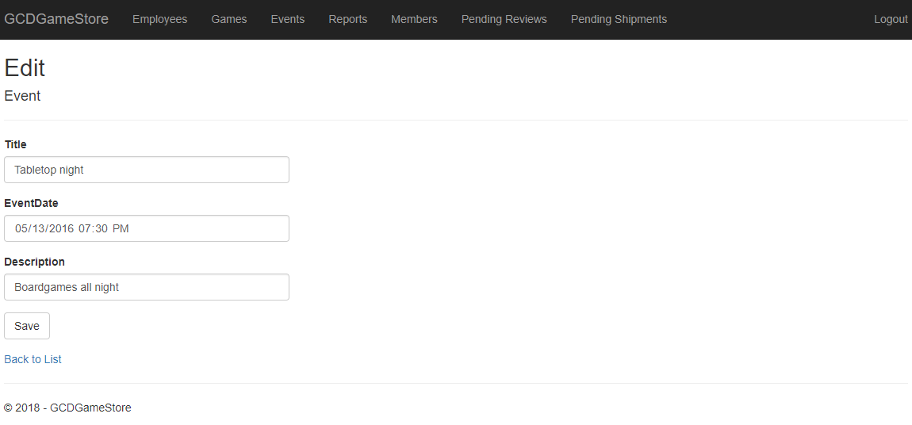

Edit the information and click save.

## Delete Event

From the view events page click Delete for an event

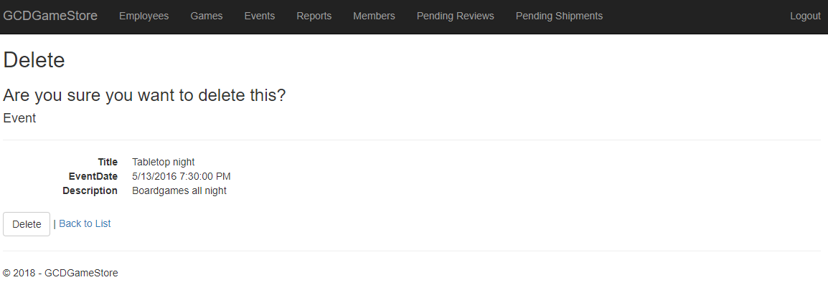

Click Delete

# Reports

## View Reports

Click Reports Menu Button

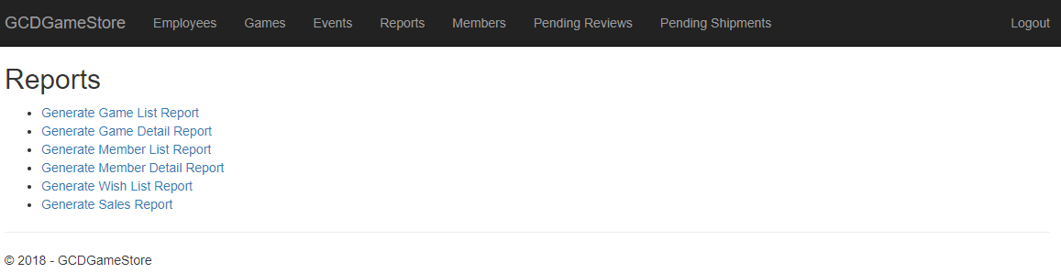

## View a Report

From the View Reports page, click on a report to view.

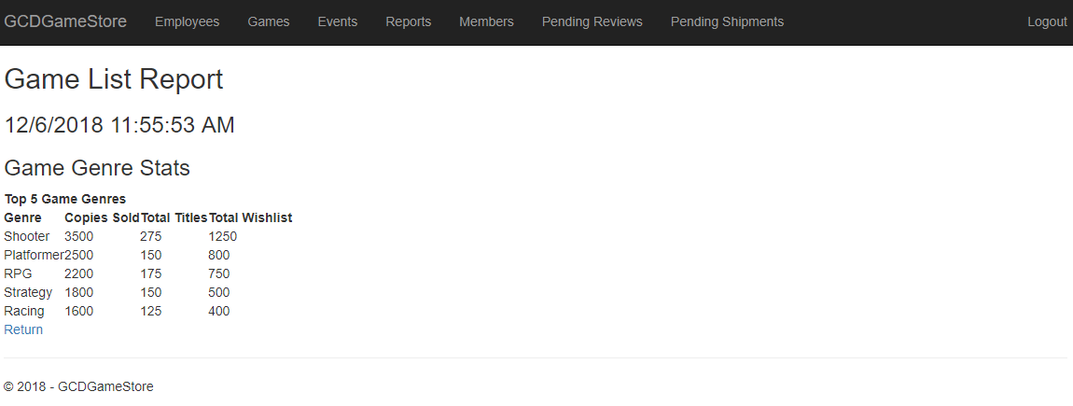

# Manage Shipments

## View Pending Shipments

Click Pending Shipments Menu Button

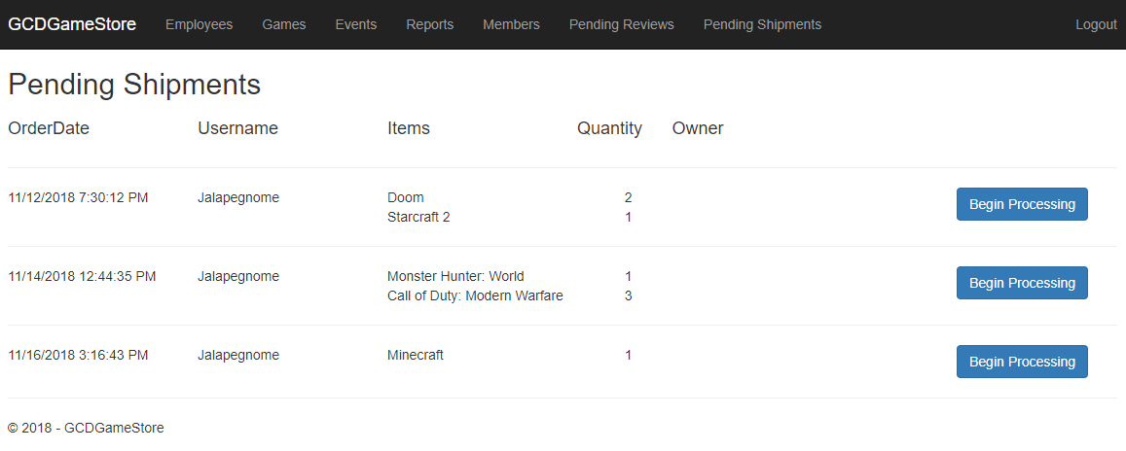

## Update Ship Status

From Pending Shipments page, click Begin Processing or Shipped, depending on the status of the shipment

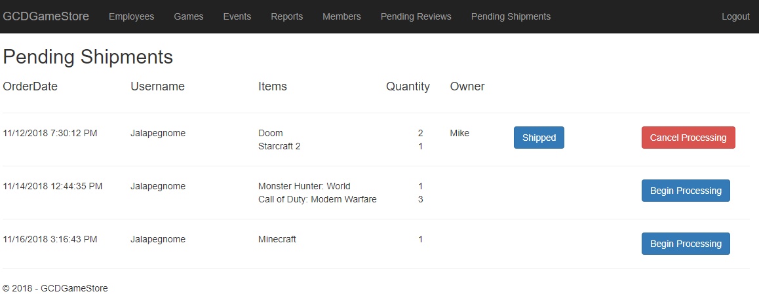

# Manage Reviews

## View Pending Reviews

Click Pending Reviews Menu Button

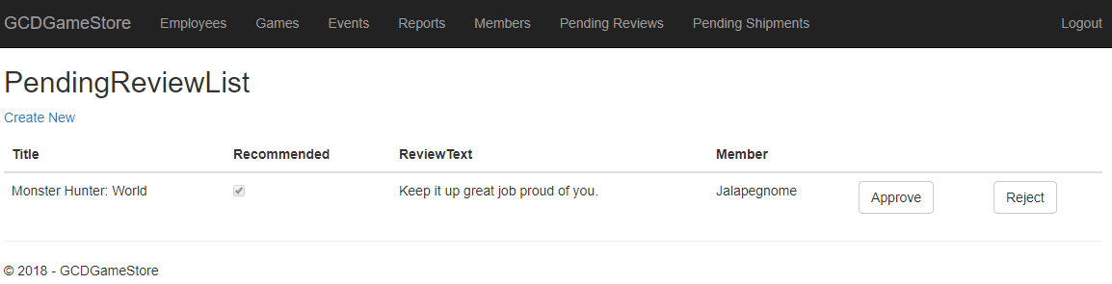

## Publish Review

Click Reject



## Reject Review

Click Approve

